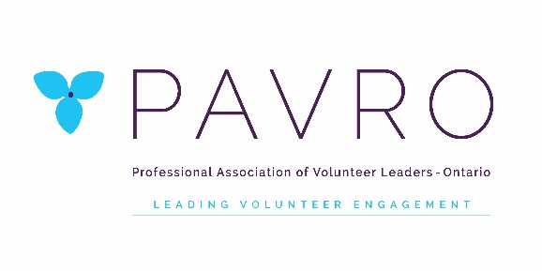
Position Description:
Past President

Purpose:
The role of the Past President is to ensure continuity during governance transitions and
organizational change, to help ensure the appropriate succession of Directors, to support the President in their role, and to provide stability to the organization by providing historical context for issues.

Responsibilities:
Under the direction of the President of the Board of Directors, the Past President’s responsibilities include:

1. Along with the Director of Volunteer Engagement, assisting with an equitable nomination process,
ensuring the needs of the Board are met to the best of ability and to present a slate of candidates
to the membership at the Annual General Meeting.
2. Regular reviewing and developing of governance policies over the course of a two year term,
continuously reviewed.
4. Routinely review and revise Bylaws, presenting any necessary changes to the membership with
due notice; provide interpretation of Bylaws and parliamentary procedures during Board meetings.
5. Participating actively in Board meetings, and/or any special meetings called by Board members or
members at large
6. Supporting the President in their position through mentoring, coaching, advising and
recommending Board development and procedures
7. Continuing to advocate for the profession and for the association wherever and whenever
possible.
8. Providing a historical context for decision-making and revising planning, objectives, etc.
9. The Past President may take on any special projects as directed by the Board or President.
10. Complete/respond to any responsibilities associated with being a Board member (attending,
preparing for, and participating in meetings/conference/AGM/retreat; financial accountability and
management of portfolio budget; reports; updating website information; policies; promoting
PAVRO; recruiting potential Board/Committee members; etc.)

Experience/Skills Required:
• A minimum of one year experience in the President position

• Strong belief in PAVRO’s mission, vision and values; able to articulate them

• Demonstrated excellent leadership skills, including previous experience as Chair of a committee or
Board

• Complete understanding of the roles, responsibilities, parliamentary procedures of not-for-profit
Boards

• A demonstrated commitment and experience in supporting best practice in the engagement of
volunteers.

• Excellent interpersonal and organizational skills as well as excellent communication skills (written
and oral) including public speaking

• Flexibility and patience

Terms:
The Past President shall attend Board, Executive and Special meetings of PAVRO for one year but may continue in the role at the discretion of the President. In the event that the President is unable to assume the role of Past President, their predecessor may be asked to continue in this position (according to PAVRO Bylaws) Must be prepared to attend all Board meetings, trainings, conferences, retreats as well as any appropriate committee or outside meetings; may need to travel on occasion

Code of Conduct
All Board members must agree to the following:
● I will perform my duties responsibly and impartially to the standards set out by PAVRO in a manner
that would bear public scrutiny.
● I agree to declare any real, apparent or perceived conflict of interest in matters which may result in
financial gain or personal benefit.
● I further agree to maintain the confidentiality of any proprietary or privileged information to which I
have access, both during and after my term on the Board of Directors. This information may include
contracts, financial information, membership lists, staffing or personnel documentation and/or
discussions about PAVRO business.

Benefits:
• Opportunity to gain a keen understanding of current happenings in the profession and broader
voluntary sector.
• Opportunity to use professional knowledge gained through PAVRO Board experience
• Opportunity to network and work closely with leaders in volunteer management from across the
province
• Opportunity to have broad input and impact on behalf of PAVRO and the profession.
• Opportunity to further the goals and ensure the stability of PAVRO
• An opportunity to develop/enhance leadership experience and be part of a team dedicated to
excellence and best practice in the engagement of volunteers.
• Reimbursement for travel expenses and long-distance phone charges (as per existing policies).

Created: March 6, 2013 Revised: December 2016

